PALAMPUR
G.G.D.S.D COLLEGE RAJPUR
SESSION 2015-2016

Submitted to H.P. University in the Partial Fulfillment of Bachelor of Computer Application Degree

UNDER THE GUIDANCE OF : SUBMITTED BY:
Mrs. Ruchi Kaushal Rishav Sood
Class-B.C.A (3rd Year)
Roll no-13314

While working on our minor project we encountered many new experiences and also several difficulties. But as each such point, we found someone is coming for our help with his full co-operation. I take the privilege in conveying heartiest gratitude to all those help unable to complete this minor project. I “sincerely and heartedly” very much thankful to our project guide, Mrs. Ruchi Kaushal, for constant help and valuable suggestions throughout the project. Her advice has greatly enhanced the worth this report.

I also appreciate and comment the supportive role – played by other Friends for helping us to complete the requirement of minor project.

After lot of days today we can say that our project is now complete and ready for implementation.

Rishav Sood

B.C.A (3rd Year)

ROLL NO.: 13314

This is to certify that this “BUS RESERVATION SYSTEM” has been designed and developed by Rishav Sood student of B.C.A Final Year under the guidance of Mrs. Ruchi Kaushal.

Date: (Signature)

STUDENT’S PROFILE

Team Members:
Sahil Sood 13326
Sahilsood480@gmail.com

Rishav Sood 13314
Rishavsood40@gmail.com

Course BCA
Project Title Bus Reservation System
Project Guide Mrs. Ruchi Kaushal

INDEX

Topic | Page No
Introduction to project
Study of Existing System
Need for Computerization
System Analysis
Data Flow Diagrams
Database Detail

Front End Used

Back End Used

Forms Detail

Coding

Testing and Implementation

Bibliography

Computers are no longer being termed, as a mere invention-it is revolution. Bus Reservation system is designed for the reservation in buses for fix routes. It generates ticket as soon as we reserve a seat in a bus. One can feed data related to buses and routes and can access as and when required. Daily Collection can be seen on single click. System is secure with a security code, by which we can enter into the system.
I have used Visual Basic 8.0 as Front End. Visual Basic is an object oriented programming language, the fastest and easiest way to create applications for Microsoft Windows. Visual Basic provides us with a complete set of tools to simplify rapid application development.
Using Microsoft Access, we can manage all your information from a single database file. Within the file, we can use Tables to store our data, Queries to find and retrieve just the data we want, Forms to view, add, and update data in tables, Reports to analyze or print data in a specific layout, Data access pages to view, update, or analyze the database's data from the Internet or an intranet. It gives the user a great deal of convenience in creating and handling database. It is becoming very popular among the users due to its user friendliness and advanced features

Before implementing this system this system was handled manually. Reservation of the passenger is done by booking clerk in a register. It was very difficult to manage these registers.
In the existing system information is kept manually the information about new routes. In spite of keeping these records, its difficult to get the required information instantly, for doing this one has to go through a pile of ledgers.
1. Mistakes are often made during calculations. Numeric calculations like the daily collection, monthly calculation, quite often results in mistakes.
2. In order to answer query, one has to see a lot of files which result in the wastage of time.
3. The manual system consumes a lot of time in paper work, a number of files have to be consulted this is the main cause of delay. The process is further slowed down by the mistake in typing, entering information into the files etc

Computers are having profound effect on the society in general and the business in particular. The repaid and drastic changes in the past two decades undoubtedly prove the worth of computers in all walks of life.
The computer applications field can be divided into basically two fields viz. Business applications and scientific applications. The difference between two types of applications is that of ratio of operations performed to that of total data processed.
In case of business data processing, the processing of large number of records is required because of the large databases. Moreover the wide variety of reports is required for providing information to the various management levels.
The main purpose of using computers is to process the data quickly, to simulate it, and give the results that are accurate and are available in real time.

Earlier system was based on paper system. There were some problems encountered in this system. On spot bus details were not available. It was difficult to search for the routes and the reservation detail.
The proposed system is user-friendly. A person can ask about reservation and can see the status whatever it is. No user can make the cheating in this system everything is fed in the files and they are only tend to make the entries.

Data flow diagram is another tool use to describe the design specification. It is also a pictorial representation of data flow. The only difference between flowchart and the data flow diagram is that DFD show only the flow of data not the actual procedure or coding to perform that function. On the other hand flowchart shows the actual calculation to perform the task.

The Different Symbol uses in DFD are:

Describe the Source and Destination of data or information. The source must be written in capital letters.

A circle used to show the process. There can be number of process in a program. Each process must be assigning a suitable number.

An open rectangle used to describe the storage of database

Arrow used to show the flow of data. A DFD can be drawn from top to bottom or from left to right

DFD’s for the System is drawn in the following page:

Process for User Login

Login Process
Bus Reservation System
System User

Process for Bus Reservation System

Booking Detail Store
Routes Detail

Bank Management System
Passenger
Request for Seats
Passenger
Ticket Detail

Database Name: -Transportation

Table Name:-BUS

Purpose: It is used to store data of Buses

Fields | Data Type | Size
Busid | Text | 50
Bustype | Text | 50
Departuretime | Date/Time | --

Database Name: -Transportation

Table Name:-Fare

Purpose: It is used to store amount according to various routes.

Fields | Data Type | Size
Bustype | Text | 50
Routeid | Text | 50
Amntadults | Number | 50

Database Name: -Transportation

Table Name:-Route

Purpose: It is used to store data of Routes

Fields | Data Type | Size
Route | Text | 30
From | Text | 30
To | Text | 30

Database Name: -Transportation

Table Name:-Ticket

Purpose: It is used to store ticket detail for printing

Fields | Data Type | Size
Customerid | Number | 50
Customername | Text | 50
Routeid | Text | 50
From | Text | 30
To | Text | 30
Busno | Text | 30
Reservationdate | Date/Time | --
Reservationtime | Date/Time | --
Seatno | Number | 30
Bustype | Text | 30
Amount | Number | 30

Database Name: -Transportation

Table Name:-Cancelticket

Purpose: It is used to store detail of cancelled tickets

Fields | Data Type | Size
Customerid | Number | 50
Customername | Text | 50
Routeid | Text | 50
From | Text | 30
To | Text | 30
Reservationdate | Date/Time | --
Reservationtime | Date/Time | --
Seatno | Number | 30
Bustype | Text | 30
Fare | Number | 30

Database Name: -Transportation

Table Name:-Usertab

Purpose: It is used to store detail of user logins.

Fields | Data Type | Size
Userid | Text | 50
Password | Text | 50

Visual Basic 8 is Microsoft’s latest and greatest A glance at Visual Basic

The areas of computer applications are literally too numerous to mention. Computers have become an integral part of man's everyday life. They dominate every phase of life be it entertainment, education, banking, insurance, research, medicine, design or manufacturing. They continue to grow and open new horizons of discovery and application.

One of the primary reasons for the immense popularity of computers is the speed with which they can accomplish specified tasks. However, computer applications are not always easy to use.

Any application has two parts:

User Interface: This is the screen displayed by the application. We interact with an application via the interface. Every application has a user interface in one form or the others. The application asks for and provide the necessary instructions using the interface.

2. Program: Computers need clear cut instruction to tell them what to do, how to do, and when to do. A set of instructions to carry out a specified task is called a program. This is what goes on in the background.

A good user interface will be:

> Easy to learn

> Easy to use

> Attractive

Why I prefer Visual Basic

Graphical User Interface:

Interface that use graphics came to be known as Graphical User Interfaces (GUI). These became very popular because the users could identify with the graphics displayed on the screen. In every day life too, we associate more with images than words. Mention the word Print to a person and it invokes the image of a printer.

The primary requirement for an interface presented to us. This is possible if the interface presented is such that it emulates real life.

Visual Programming:

Visual Programming aims at providing the user with an interface that is intuitive and easy-to-use. In developing such an interface, the programmer employs user-friendly features such as windows, menus, buttons and list boxes.

A visual programming environment provides all features that are required to develop a graphical user interface as ready-to-use components. The programmer does not have to write code to create and display commonly required user-friendly features each time around.

Advantages of Visual Programming:

1. Visual programming enablesVisual development of graphical user interfaces which are easy to use and easy to learn.

2. A programmer need not write code to display the required component. The visual programming environment displays a list of available components. The programmer picks up the required component from this list to display it.

3. Component can be moved, resized and even deleted, if so required.

4. There is no restriction on the number of controls that can be used.

5. The interface components provided by the visual programming environment have some code built into them.

6. The programmer can create the user interface visually; he can align, move or size the components as required without having to resort to writing code.

Disadvantages of Visual Programming:

While visual programming makes it very simple to create complex user interfaces, it suffers from some disadvantages:

1. As the name implies, the entire process of developing an application using a visual development environment is visual. Thus the development environment in itself is highly graphical is nature and therefore requires more memory.

2. Visual development environment require computers of a highs configuration in comparison to the conventional programming tools:

> Larger capacity hard disk

> More RAM

Faster Processor

3. Primarily, visual development environment can be used only with GUI operating systems such as windows.

Events:

A major part of the interactions between people in every day life is in the form of events and responses to events. An event is any action directed at the application. An event driven application operates by responding to the user events. The ability to recognize events is built into interface components. The events that an interface component recognizes are different for each type of component.

A database is a collection of information that's related to a particular subject or purpose, such as tracking customer orders or maintaining a collection. If your database isn't stored on a computer, or only parts of it are, you may be tracking information from a variety of sources that you have to coordinate and organize yourself.
Access database files
Using Microsoft Access, you can manage all your information from a single database file. Within the file, you can use:
· Tables to store your data.
· Queries to find and retrieve just the data you want.
· Forms to view, add, and update data in tables.
· Reports to analyze or print data in a specific layout.
· Data access pages to view, update, or analyze the database's data from the Internet or an intranet.
Tables and relationship
To store your data, create one table for each type of information that you track. To bring the data from multiple tables together in a query, form, report, or data access page, define relationships between the tables.
Relationship in a database
After you've set up different tables for each subject in your Microsoft Access database, you need a way of telling Microsoft Access how to bring that information back together again. The first step in this process is to define relationship between your tables. After you've done that, you can create queries, forms, and reports to display information from several tables at once.
- One-to-many relationship
- Many-to-many relationship
- One-to-one relationship

Queries
To find and retrieve just the data that meets conditions that you specify, including data from multiple tables, create a query. A query can also update or delete multiple records at the same time, and perform predefined or custom calculations on your data.
About designing a database Good database design ensures that your database is easy to maintain. You store data in tables and each table contains data about only one subject, such as customers. Therefore, you update a particular piece of data, such as an address, in just one place and that change automatically appears throughout the database.
A well-designed database usually contains different types of queries that show the information you need. A query might show a subset of data, such as all customers in Delhi, or combinations of data from different tables, such as order information combined with customer information.

Hardware Requirement

Monitor-Color Monitor, having pixel setting(640*480), true colors

Hard Disk-4GB to 40GB

RAM-Minimum 2 GB

CD ROM/Writer

Mouse

Keyboard

Software Requirement:
- Front End-Visual Basic 8.0
- Back End-MS-Access
- Windows operating System

LOGIN FORM

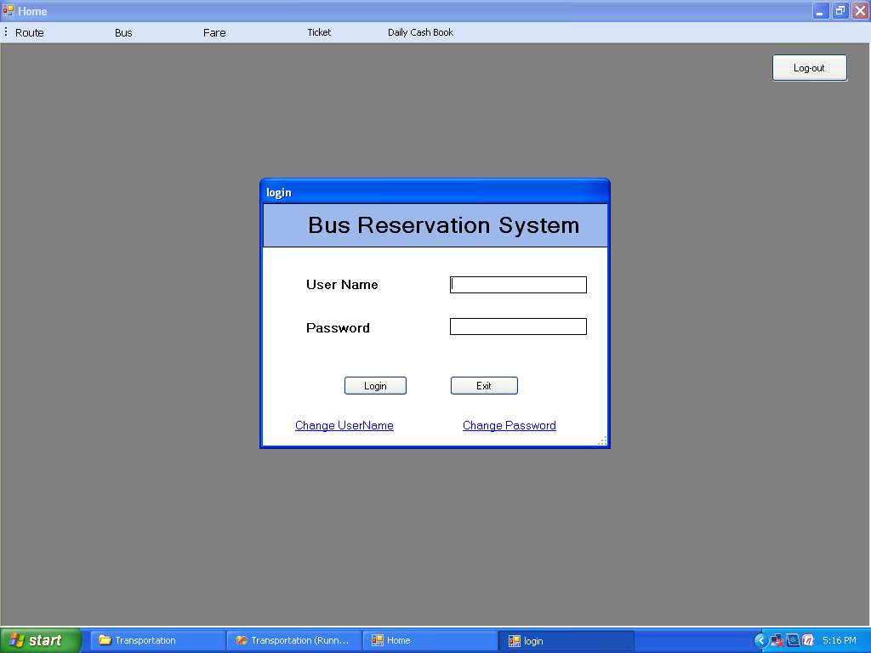

Main Form

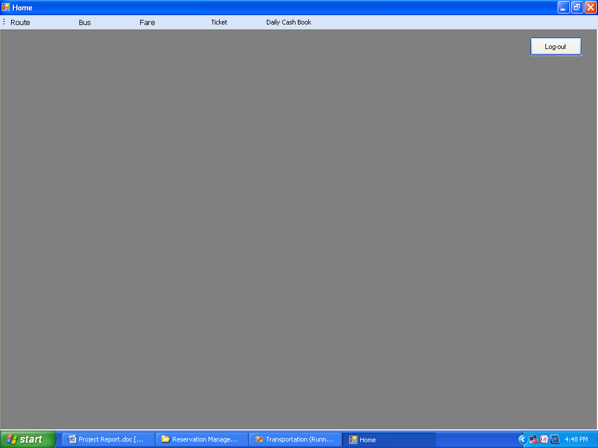

This is the opening form it contains all the menus. It is starting and end point of the project

Log Out-This button is used to exit from particular user account.

New Bus Detail Entry Form

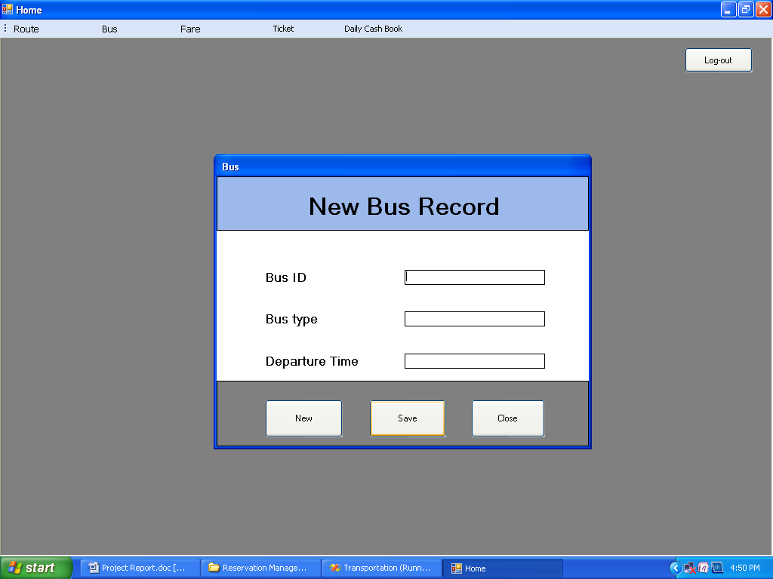

This form is to create new bus detail
New -This button is used to enter new records
Save-This button is used to save the records
Close-This button is used to close the form
Route Detail Form

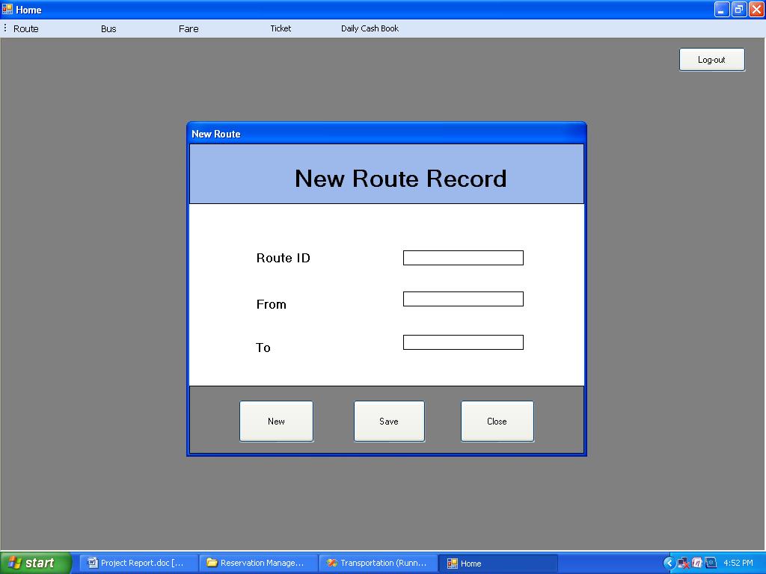

This form is used to enter the detail of routes
New -This button is used to enter new records
Save-This button is used to save the records
Close-This button is used to close the form
Fare Detail Form

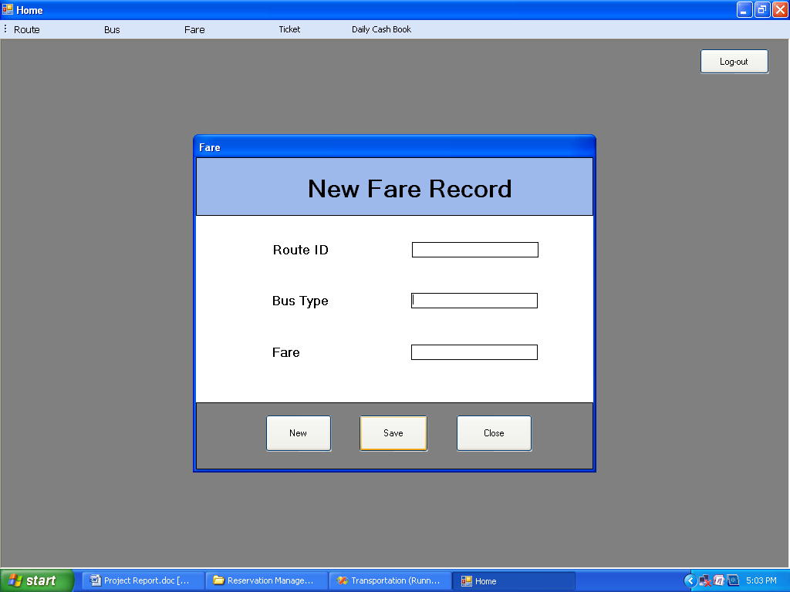

New -This button is used to enter new fare record
Save-This button is used to save the fare record
Close-This button is used to close the form

Ticket Booking Form

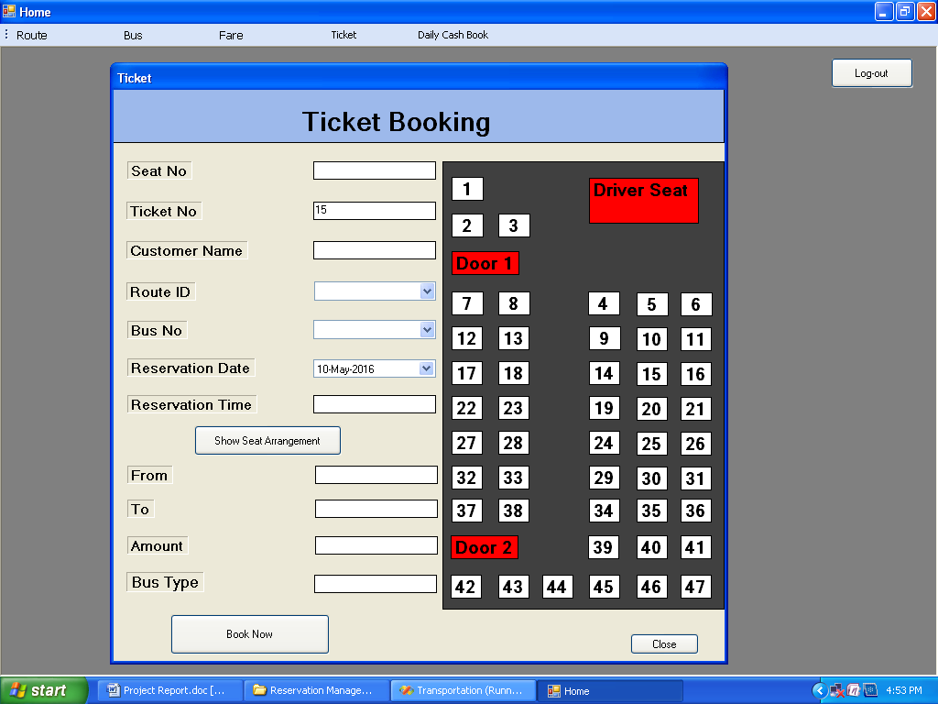

This form is used to reserve seat

Book now-This button is used to reserve ticket
Show Seat Arrangment-This button is used to show seat arrangement
Close-This button is used to close the form

Daily Collection Report

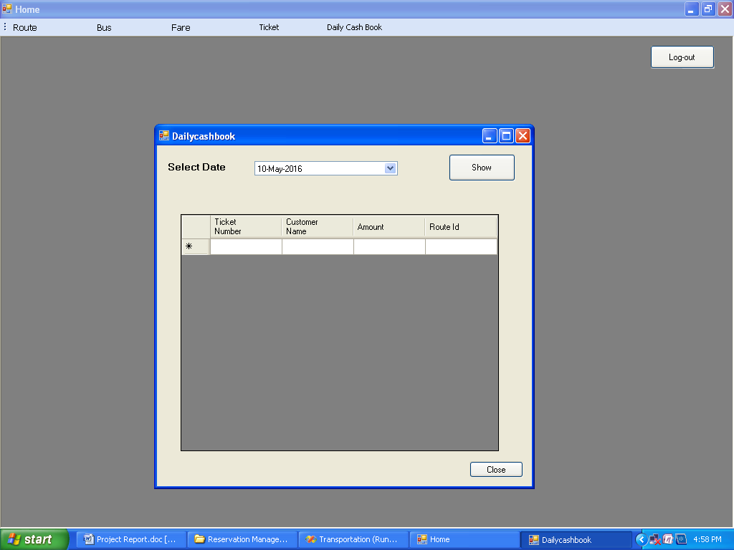

This form is used to find total collection in a day.

Exit-This button is used to close the form

Ticket Cancelling

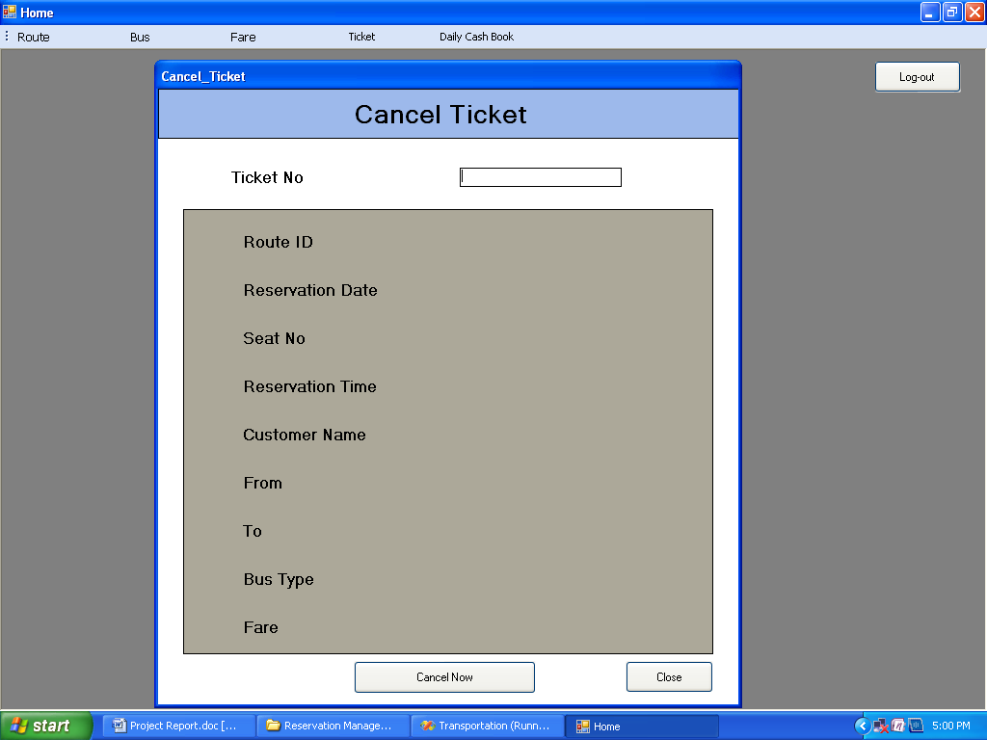

Cancel Now: This button is used to Cancel the ticket.
Close: This button is used to close the form.
Fare Detail Form

New -This button is used to enter new fare record
Save-This button is used to save the fare record
Close-This button is used to close the form
Print Ticket

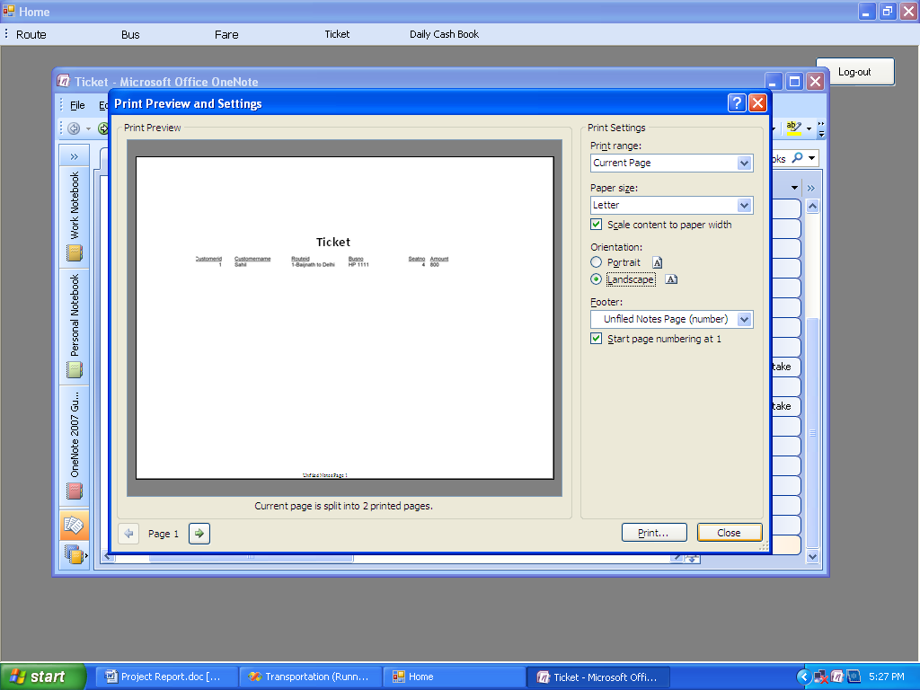

- This form is used to Print the Ticket

LogIn Form

Public Class login
Dim con As New ADODB.Connection
Dim rs As New ADODB.Recordset

Private Sub login_Load(ByVal sender As System.Object, ByVal e As System.EventArgs) Handles MyBase.Load

con.Open("Provider=Microsoft.ACE.OLEDB.12.0;Data Source=D:\Reservation Management System\Transportation.accdb;Persist Security Info=False")

End Sub

Private Sub cmdlogin_Click(ByVal sender As System.Object, ByVal e As System.EventArgs) Handles cmdlogin.Click
rs.Open("select * from Usertab where userid='" & txtuser.Text & "' and password='" & txtpass.Text & "'", con, ADODB.CursorTypeEnum.adOpenDynamic, ADODB.LockTypeEnum.adLockOptimistic)
If Not rs.EOF Then
main.Show()
Me.Close()
Else
MsgBox("Invalid User OR Password ", MsgBoxStyle.Critical, "Invalid Login")

End If
rs.Close()
txtpass.Text = ""
txtuser.Text = ""
con.Close()

End Sub

Private Sub cmdexit_Click(ByVal sender As System.Object, ByVal e As System.EventArgs) Handles cmdexit.Click
End

End Sub

Private Sub LinkLabel1_LinkClicked(ByVal sender As System.Object, ByVal e As System.Windows.Forms.LinkLabelLinkClickedEventArgs) Handles LinkLabel1.LinkClicked
Changpass.Show()

End Sub

Private Sub LinkLabel2_LinkClicked(ByVal sender As System.Object, ByVal e As System.Windows.Forms.LinkLabelLinkClickedEventArgs) Handles LinkLabel2.LinkClicked
Changusernm.Show()
End Sub

End Class

Main Form
Public Class main

Private Sub NewToolStripMenuItem_Click(ByVal sender As System.Object, ByVal e As System.EventArgs) Handles NewToolStripMenuItem.Click
route.Show()
End Sub

Private Sub ModifyToolStripMenuItem_Click(ByVal sender As System.Object, ByVal e As System.EventArgs) Handles ModifyToolStripMenuItem.Click
EditRoute.Show()
End Sub

Private Sub DeleteToolStripMenuItem_Click(ByVal sender As System.Object, ByVal e As System.EventArgs) Handles DeleteToolStripMenuItem.Click
Delroute.Show()
End Sub

Private Sub NewBusRecordToolStripMenuItem_Click(ByVal sender As System.Object, ByVal e As System.EventArgs) Handles NewBusRecordToolStripMenuItem.Click
busform.Show()
End Sub

Private Sub EditBusRecordToolStripMenuItem_Click(ByVal sender As System.Object, ByVal e As System.EventArgs) Handles EditBusRecordToolStripMenuItem.Click
EditBus.Show()
End Sub

Private Sub DeleteBusRecordToolStripMenuItem_Click(ByVal sender As System.Object, ByVal e As System.EventArgs) Handles DeleteBusRecordToolStripMenuItem.Click
Delbus.Show()
End Sub

Private Sub NewFareRecordToolStripMenuItem_Click(ByVal sender As System.Object, ByVal e As System.EventArgs) Handles NewFareRecordToolStripMenuItem.Click
Fare.Show()

End Sub

Private Sub EditFareRecordToolStripMenuItem_Click(ByVal sender As System.Object, ByVal e As System.EventArgs) Handles EditFareRecordToolStripMenuItem.Click
Editfare.Show()

End Sub

Private Sub DeleteFareRecordToolStripMenuItem_Click(ByVal sender As System.Object, ByVal e As System.EventArgs) Handles DeleteFareRecordToolStripMenuItem.Click
delfare.Show()
End Sub

Private Sub TicketToolStripMenuItem_Click(ByVal sender As System.Object, ByVal e As System.EventArgs) Handles TicketToolStripMenuItem.Click

End Sub

Private Sub main_Load(ByVal sender As System.Object, ByVal e As System.EventArgs) Handles MyBase.Load
login.ShowDialog()
End Sub

Private Sub DailyCashBookToolStripMenuItem_Click(ByVal sender As System.Object, ByVal e As System.EventArgs) Handles DailyCashBookToolStripMenuItem.Click
Dailycashbook.Show()
End Sub

Private Sub Button1_Click(ByVal sender As System.Object, ByVal e As System.EventArgs) Handles Button1.Click
login.ShowDialog()
End Sub

Private Sub TicketBookingToolStripMenuItem_Click(ByVal sender As System.Object, ByVal e As System.EventArgs) Handles TicketBookingToolStripMenuItem.Click
Ticket.Show()
End Sub

Private Sub TicketCancellingToolStripMenuItem_Click(ByVal sender As System.Object, ByVal e As System.EventArgs) Handles TicketCancellingToolStripMenuItem.Click
Cancel_Ticket.Show()
End Sub
End Class

New Bus Record Form

Public Class busform
Dim con As New ADODB.Connection
Dim rs As New ADODB.Recordset

Private Sub cmdcls_Click(ByVal sender As System.Object, ByVal e As System.EventArgs) Handles cmdcls.Click
Me.Close()
End Sub

Private Sub cmdnew_Click(ByVal sender As System.Object, ByVal e As System.EventArgs) Handles cmdnew.Click

txtbid.Text = ""
txtbtyp.Text = ""

txtbtime.Text = ""

End Sub

Private Sub cmdsav_Click(ByVal sender As System.Object, ByVal e As System.EventArgs) Handles cmdsav.Click
rs.AddNew()
rs.Fields("Busid").Value = txtbid.Text
rs.Fields("Bustype").Value = txtbtyp.Text

rs.Fields("Departuretime").Value = txtbtime.Text
rs.Update()
MsgBox("Record Saved")

End Sub

Private Sub busform_Load(ByVal sender As System.Object, ByVal e As System.EventArgs) Handles MyBase.Load
Me.MdiParent = main

con.Open("Provider=Microsoft.ACE.OLEDB.12.0;Data Source=D:\Reservation Management System\Transportation.accdb;Persist Security Info=False")
rs.Open("Bus", con, ADODB.CursorTypeEnum.adOpenDynamic, ADODB.LockTypeEnum.adLockOptimistic)

End Sub
End Class

New Fare Form

Public Class Fare
Dim con As New ADODB.Connection
Dim rs As New ADODB.Recordset

Private Sub Fare_Load(ByVal sender As System.Object, ByVal e As System.EventArgs) Handles MyBase.Load
Me.MdiParent = main
con.Open("Provider=Microsoft.ACE.OLEDB.12.0;Data Source=D:\Reservation Management System\Transportation.accdb;Persist Security Info=False")
rs.Open("Fare", con, ADODB.CursorTypeEnum.adOpenDynamic, ADODB.LockTypeEnum.adLockOptimistic)

End Sub

Private Sub cmdnew_Click(ByVal sender As System.Object, ByVal e As System.EventArgs) Handles cmdnew.Click
txtbtyp.Text = ""
txtffadul.Text = ""
txtrid.Text = ""

End Sub

Private Sub cmdcls_Click(ByVal sender As System.Object, ByVal e As System.EventArgs) Handles cmdcls.Click
Me.Close()
End Sub

Private Sub cmdsave_Click(ByVal sender As System.Object, ByVal e As System.EventArgs) Handles cmdsave.Click
rs.AddNew()
rs.Fields("Bustype").Value = txtbtyp.Text
rs.Fields("Routeid").Value = txtrid.Text
rs.Fields("Amntadults").Value = txtffadul.Text
rs.Update()
MsgBox("Record Saved")

End Sub
End Class
New Route Form

Public Class route
Dim con As New ADODB.Connection
Dim rs As New ADODB.Recordset

Private Sub route_Load(ByVal sender As System.Object, ByVal e As System.EventArgs) Handles MyBase.Load
Me.MdiParent = main
con.Open("Provider=Microsoft.ACE.OLEDB.12.0;Data Source=D:\Reservation Management System\Transportation.accdb;Persist Security Info=False")
rs.Open("Route", con, ADODB.CursorTypeEnum.adOpenDynamic, ADODB.LockTypeEnum.adLockOptimistic)

End Sub

Private Sub cmdsave_Click(ByVal sender As System.Object, ByVal e As System.EventArgs) Handles cmdsave.Click
rs.AddNew()
rs.Fields("Routeid").Value = txtrid.Text
rs.Fields("From").Value = txtfrm.Text
rs.Fields("To").Value = txtdesti.Text
rs.Update()
MsgBox("Record saved")

End Sub

Private Sub cmdnew_Click(ByVal sender As System.Object, ByVal e As System.EventArgs) Handles cmdnew.Click
txtdesti.Text = ""
txtfrm.Text = ""
txtrid.Text = ""

End Sub

Private Sub cmdcls_Click(ByVal sender As System.Object, ByVal e As System.EventArgs) Handles cmdcls.Click
Me.Close()

End Sub
End Class
Ticket Form

Public Class Ticket
Dim x As Integer
Dim seat() As Label
Dim lb As Label
Dim con As New ADODB.Connection
Dim con1 As New ADODB.Connection
Dim rs, rs4 As New ADODB.Recordset
Dim rs1 As New ADODB.Recordset
Dim rs2 As New ADODB.Recordset
Dim rs3 As New ADODB.Recordset
Dim rs5 As New ADODB.Recordset
Dim temprs As New ADODB.Recordset

Private Sub Ticket_Load(ByVal sender As System.Object, ByVal e As System.EventArgs) Handles MyBase.Load
Me.MdiParent = main
con.Open("Provider=Microsoft.ACE.OLEDB.12.0;Data Source=D:\Reservation Management System\Transportation.accdb;Persist Security Info=False")
con1.Open("Provider=Microsoft.ACE.OLEDB.12.0;Data Source=D:\Reservation Management System\report.mdb;Persist Security Info=False")
rs.Open("Ticket", con, ADODB.CursorTypeEnum.adOpenDynamic, ADODB.LockTypeEnum.adLockOptimistic)
rs4.Open("select Count(*)+1 as Num from Ticket", con, ADODB.CursorTypeEnum.adOpenDynamic, ADODB.LockTypeEnum.adLockOptimistic)
rs5.Open("Printticket", con1, ADODB.CursorTypeEnum.adOpenDynamic, ADODB.LockTypeEnum.adLockOptimistic)

'MsgBox(rs4.Fields("Num").Value)
rs1.Open("select * from Bus", con, ADODB.CursorTypeEnum.adOpenDynamic, ADODB.LockTypeEnum.adLockOptimistic)
rs2.Open("select * from Route", con, ADODB.CursorTypeEnum.adOpenDynamic, ADODB.LockTypeEnum.adLockOptimistic)
rs3.Open("Fare", con, ADODB.CursorTypeEnum.adOpenDynamic, ADODB.LockTypeEnum.adLockOptimistic)
txtcusid.Text = rs4.Fields("Num").Value

While Not rs1.EOF
cbbus.Items.Add(rs1.Fields("Busid").Value)
rs1.MoveNext()
End While
rs1.Close()
While Not rs2.EOF
cbrout.Items.Add(rs2.Fields("Routeid").Value)
rs2.MoveNext()
End While

rs2.Close()

x = 0
seat = New Label() {Seat1, Seat2, Seat3, Seat4, Seat5, Seat6, Seat7, Seat8, Seat9, Seat10, Seat11, Seat12, Seat13, Seat14, Seat15, Seat16, Seat17, Seat18, Seat19, Seat20, Seat21, Seat22, Seat23, Seat24, Seat25, Seat26, Seat27, Seat28, Seat29, Seat30, Seat31, Seat32, Seat33, Seat34, Seat35, Seat36, Seat37, Seat38, Seat39, Seat40, Seat41, Seat42, Seat43, Seat44, Seat45, Seat46, Seat47}
For i = 0 To 46
seat(i).BackColor = Color.White
Next

End Sub

Private Sub Button1_Click(ByVal sender As System.Object, ByVal e As System.EventArgs) Handles Button1.Click
con1.Execute("delete from Printticket")
rs5.AddNew()
rs5.Fields("Customerid").Value = txtcusid.Text
rs5.Fields("Customername").Value = txtcusnm.Text
rs5.Fields("Routeid").Value = cbrout.Text
rs5.Fields("Busno").Value = cbbus.Text
rs5.Fields("Reservationdate").Value = dtpdate.Text
rs5.Fields("Reservationtime").Value = txttim.Text
rs5.Fields("Seatno").Value = txtseatno.Text
rs5.Fields("Amount").Value = txtamnt.Text
rs5.Fields("From").Value = txtfrm.Text
rs5.Fields("To").Value = txtto.Text
rs5.Update()
rs5.Close()
For i = 1 To 100
report.Refresh()
Next

rs.AddNew()
rs.Fields("Customerid").Value = txtcusid.Text
rs.Fields("Customername").Value = txtcusnm.Text
rs.Fields("Routeid").Value = cbrout.Text
rs.Fields("Busno").Value = cbbus.Text
rs.Fields("Reservationdate").Value = dtpdate.Text
rs.Fields("Reservationtime").Value = txttim.Text
rs.Fields("Seatno").Value = txtseatno.Text
rs.Fields("Amount").Value = txtamnt.Text
rs.Fields("From").Value = txtfrm.Text
rs.Fields("To").Value = txtto.Text
rs.Update()

MsgBox("Record saved")
txtamnt.Text = ""
txtbtyp.Text = ""
txtcusid.Text = ""
txtcusnm.Text = ""
txtfrm.Text = ""
txtseatno.Text = ""
txttim.Text = ""
txtto.Text = ""
cbbus.Text = ""
cbrout.Text = ""
report.PrintToPrinter(1, True, 0, 0)

End Sub

Private Sub cbbus_SelectedIndexChanged(ByVal sender As System.Object, ByVal e As System.EventArgs) Handles cbbus.SelectedIndexChanged
rs1.Open("select * from Bus where Busid='" & cbbus.Text & "'", con, ADODB.CursorTypeEnum.adOpenDynamic, ADODB.LockTypeEnum.adLockOptimistic)
txtbtyp.Text = rs1.Fields("Bustype").Value
txttim.Text = rs1.Fields("Departuretime").Value

rs1.Close()

End Sub

Private Sub cbrout_SelectedIndexChanged(ByVal sender As System.Object, ByVal e As System.EventArgs) Handles cbrout.SelectedIndexChanged
rs2.Open("select * from Fare where Routeid='" & cbrout.Text & "'", con, ADODB.CursorTypeEnum.adOpenDynamic, ADODB.LockTypeEnum.adLockOptimistic)
txtamnt.Text = rs2.Fields("Amntadults").Value
rs2.Close()
rs2.Open("select * from Route where Routeid='" & cbrout.Text & "'", con, ADODB.CursorTypeEnum.adOpenDynamic, ADODB.LockTypeEnum.adLockOptimistic)
txtfrm.Text = rs2.Fields("From").Value
txtto.Text = rs2.Fields("To").Value
rs2.Close()
End Sub

Private Sub Seat1_Click(ByVal sender As System.Object, ByVal e As System.EventArgs) Handles Seat1.Click, Seat2.Click, Seat3.Click, Seat4.Click, Seat5.Click, Seat6.Click, Seat7.Click, Seat8.Click, Seat9.Click, Seat10.Click, Seat11.Click, Seat12.Click, Seat13.Click, Seat14.Click, Seat15.Click, Seat16.Click, Seat17.Click, Seat18.Click, Seat19.Click, Seat20.Click, Seat21.Click, Seat22.Click, Seat23.Click, Seat24.Click, Seat25.Click, Seat26.Click, Seat27.Click, Seat28.Click, Seat29.Click, Seat30.Click, Seat31.Click, Seat32.Click, Seat33.Click, Seat34.Click, Seat35.Click, Seat36.Click, Seat37.Click, Seat38.Click, Seat39.Click, Seat40.Click, Seat41.Click, Seat42.Click, Seat43.Click, Seat44.Click, Seat45.Click, Seat46.Click, Seat47.Click
lb = sender
For i = 0 To 46
If lb.Text = seat(i).Text Then
If seat(i).BackColor = Color.GreenYellow Then
txtseatno.Text = ""
seat(i).BackColor = Color.White
Else
seat(i).BackColor = Color.GreenYellow
txtseatno.Text = lb.Text
End If
End If
Next
End Sub

Private Sub cmddetail_Click(ByVal sender As System.Object, ByVal e As System.EventArgs) Handles cmddetail.Click
temprs.Open("select seatno from ticket where busno='" & cbbus.Text & "' and routeid='" & cbrout.Text & "' and reservationdate=#" & dtpdate.Text & "#", con, ADODB.CursorTypeEnum.adOpenDynamic, ADODB.LockTypeEnum.adLockOptimistic)
For i = 0 To 46
seat(i).BackColor = Color.White
Next
If Not temprs.EOF Then
For i = 0 To 46
temprs.MoveFirst()
While Not temprs.EOF
If temprs.Fields("seatno").Value = seat(i).Text Then
seat(i).BackColor = Color.GreenYellow
End If
temprs.MoveNext()
End While
Next
End If
temprs.Close()
End Sub

Private Sub cmdclose_Click(ByVal sender As System.Object, ByVal e As System.EventArgs) Handles cmdclose.Click
Me.Close()
End Sub
End Class
Private Sub cmdsave_Click(ByVal sender As System.Object, ByVal e As System.EventArgs) Handles cmdsave.Click
rs.AddNew()
rs.Fields("Bustype").Value = txtbtyp.Text
rs.Fields("Routeid").Value = txtrid.Text
rs.Fields("Amntadults").Value = txtffadul.Text
rs.Update()
MsgBox("Record Saved")

End Sub
End Class

Daily Cash Book Form

Public Class Dailycashbook
Dim con As New ADODB.Connection
Dim rs As New ADODB.Recordset

Private Sub Dailycashbook_Load(ByVal sender As System.Object, ByVal e As System.EventArgs) Handles MyBase.Load
con.Open("Provider=Microsoft.ACE.OLEDB.12.0;Data Source=D:\Reservation Management System\Transportation.accdb;Persist Security Info=False")

End Sub

Private Sub cmdshow_Click(ByVal sender As System.Object, ByVal e As System.EventArgs) Handles cmdshow.Click
Dim tot As Double
tot = 0
rs.Open("select * from Ticket where Reservationdate= #" & dtp1.Text & "# ", con, ADODB.CursorTypeEnum.adOpenDynamic, ADODB.LockTypeEnum.adLockOptimistic)

grid.Rows.Clear()
While Not rs.EOF
grid.Rows.Add(rs.Fields("customerid").Value, rs.Fields("Customername").Value, rs.Fields("amount").Value, rs.Fields("Routeid").Value)
tot = tot + Val(rs.Fields("Amount").Value)
rs.MoveNext()
End While

rs.Close()

End Sub

Private Sub cmdcls_Click(ByVal sender As System.Object, ByVal e As System.EventArgs) Handles cmdcls.Click
Me.Close()
End Sub

End Class

Ticket Cancelling

Public Class Cancel_Ticket
Dim con As New ADODB.Connection
Dim rs1 As New ADODB.Recordset
Dim rs2 As New ADODB.Recordset

Private Sub Cancel_Ticket_Load(ByVal sender As System.Object, ByVal e As System.EventArgs) Handles MyBase.Load
con.Open("Provider=Microsoft.ACE.OLEDB.12.0;Data Source=D:\Reservation Management System\Transportation.accdb;Persist Security Info=False")
rs2.Open("Cancelticket", con, ADODB.CursorTypeEnum.adOpenDynamic, ADODB.LockTypeEnum.adLockOptimistic)
Me.MdiParent = main
End Sub

Private Sub txtcid_KeyDown(ByVal sender As Object, ByVal e As System.Windows.Forms.KeyEventArgs) Handles txtcid.KeyDown
If e.KeyCode = Keys.Enter Then
rs1.Open("select * from Ticket where Customerid=" & txtcid.Text, con, ADODB.CursorTypeEnum.adOpenDynamic, ADODB.LockTypeEnum.adLockOptimistic)
lblbtyp.Text = rs1.Fields("Bustype").Value
lblcname.Text = rs1.Fields("Customername").Value
lblfare.Text = rs1.Fields("Amount").Value
lblrdate.Text = rs1.Fields("Reservationdate").Value
lblrid.Text = rs1.Fields("Routeid").Value
lblrtime.Text = rs1.Fields("Reservationtime").Value
lblseatno.Text = rs1.Fields("Seatno").Value
lblto.Text = rs1.Fields("To").Value
lblfrm.Text = rs1.Fields("from").Value
rs1.Close()
End If
End Sub

Private Sub Button1_Click(ByVal sender As System.Object, ByVal e As System.EventArgs) Handles Button1.Click
Dim ans As MsgBoxResult
ans = MsgBox("Are you sure want to delete record ?", MsgBoxStyle.YesNo, "Confirmation")
If ans = MsgBoxResult.Yes Then

rs2.AddNew()
rs2.Fields("Customerid").Value = txtcid.Text

rs2.Fields("Bustype").Value = lblbtyp.Text
rs2.Fields("Customername").Value = lblcname.Text
rs2.Fields("Fare").Value = lblfare.Text

rs2.Fields("Reservationdate").Value = lblrdate.Text

rs2.Fields("Routeid").Value = lblrid.Text

rs2.Fields("Reservationtime").Value = lblrtime.Text
rs2.Fields("Seatno").Value = lblseatno.Text
rs2.Fields("To").Value = lblto.Text

rs2.Fields("from").Value = lblfrm.Text
rs2.Update()
rs1.Open("Ticket", con, ADODB.CursorTypeEnum.adOpenDynamic, ADODB.LockTypeEnum.adLockOptimistic)
rs1.Delete()
MsgBox("Ticket Is Cancelled")
rs1.Close()
txtcid.Text = ""
lblbtyp.Text = ""
lblcname.Text = ""
lblfare.Text = ""
lblfrm.Text = ""
lblrdate.Text = ""
lblrid.Text = ""
lblrtime.Text = ""
lblseatno.Text = ""
lblto.Text = ""
End If
End Sub

Private Sub cmdcls_Click(ByVal sender As System.Object, ByVal e As System.EventArgs) Handles cmdcls.Click
Me.Close()
End Sub
End Class

Testing forms the first step in determining the errors in a program, the success of testing in revealing errors in programs depends critically on the test cases. Testing can be broken into smaller activities, due to this incremental testing is generally performed, in which components and subsystems of the system are tested separately before integrating them. The basic purpose of the testing is to detect the errors that may be present in the program, there are two basic approaches to testing: Functional and Structural.
Functional Testing: In the functional testing the structure of the program is not considered, test cases are decided on the basis of the requirements or specifications of the program or module and the internals of the module or the program are not considered for selection of the test cases. Due to this nature, it is often called Black box testing
Structural Testing: In Structural testing test cases are generated based on the actual code of the program or module to be tested, it deals with the internal structure of the program responsible for actually implementing that function, this approach is sometimes called glass box testing

System Testing
- The raw data is fed in the database.
- The Module is working in a good condition.
- Functional testing and Structural testing was done.

In the implementation phase Programs are written, files and data bases are created, Education and training of user takes place, system is tested with optional data. Then changeover takes place in the old system is replaced by new one. The implementation of a system may take place when: -
- The target date of chance over is due.
- The system has been proved to the satisfaction of system analyst and other implementation activities have been completed.
- The user manager is satisfied with the results of testing, staff training and reference manuals.
- Operation manager is satisfied with the performance of equipments and operation staff.
There are different methods of changeover for example: -
- Direct Changeover: In this method of changeover the old system is replaced by new system in one move.
- Parallel Changeover: In this method of changeover, the processing of data takes place by both old and new system to cross check the results.
- Staged Changeover: A staged changeover consists of a series of limited size changeover. In this method the new system is introduced piece by piece.
Pilot Running: In this method historical data for the whole or part of the system is run on this system and results obtained from the new system are compared with old system.

Visual Basic
- Mastering Visual Basic 8.0
- Teach Yourself Visual Basic 8.0
- Super Bible of Visual Basic
Software Engineering
- An Integrated Approach to Software Engineering (Pankaj Jalote)
- System Analysis and Designing (Awad)
Database Management System
- Fundamentals of Database System (Elmasri, Navathe)
- An Introduction to Database Systems (C.J.Date)

